Year 1 Long Term Plan

Our curriculum has key aims and values that we refer to as threads. These five threads are entwined through all areas of the curriculum.

Oracy | Enrichment   | Identity   | Equality and Diversity  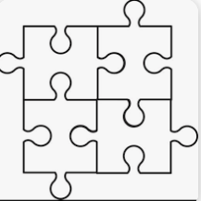 | Inspiration and Aspiration  

 | Autumn 1 | Autumn 2 | Spring 1 | Spring 2 | Summer 1 | Summer 2
Phonics | Phase 5 | Phase 5 | Phase 5 | Phase 5 | Phase 5 | Phase 5
English | Core Text:  Lost and Found by Oliver Jeffers  Adventure story  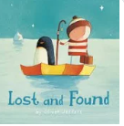 | Core Text:  Nibbles the book monster  by Emma Yarlett  Diary entry  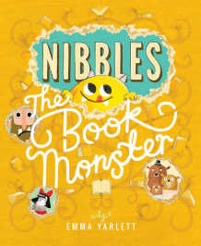 | Core Text:  The Lion inside  by Rachel Bright  Journey Story  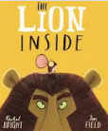 | Core Text:  The curious case of the missing mammoth  by Ellie Hattie  Adventure story with a change of character  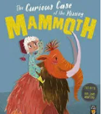 | Core Text:  Toys in space  by Mini Grey  Fantasy story  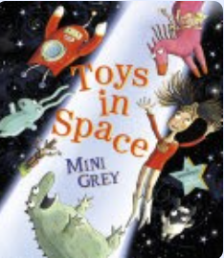 | Core Text:  Goldilocks and Just the One Bear  by Leigh Hodgkinson  Traditional story with a new character  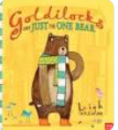
Maths | Place Value within 10  Number, addition and subtraction within 10 | Number, addition and subtraction within 10  Geometry (shape)  Number, place value within 20 | Number, addition and subtraction within 20  Number, place value within 50 | Number, place value within 50  Measurement, length and height.  Measurement, weight and volume | Number, multiplication and division  Number fractions | Geometry, position and direction  Number, place value within 100  Measurement, money and time
Science | Everyday materials | Animals including humans | Plants | Everyday materials | Plants | Animals including humans
Geography/ History | Geography  The Local Area  (Our School, Our Street)   | History  Concepts of past and present, old and new (Toys) | Geography  Human and physical features in our local area  (Blackburn) | History  Significant places in our local area  (Leeds and Liverpool Canal) | Geography  Name and locate countries of the UK | History  Lives of significant individuals  (David Attenborough)
Art / Design Technology | Art  Drawing: Make your mark | Design Technology  Textiles: Puppets | Design Technology  Mechanisms: Making a moving storybook | ART  Painting and Mixed media: Colour Splash | Design Technology  Cooking and Nutrition: Smoothies | ART  Sculpture and 3D: Paper Play
Computing | Online Safety– Own Your Creative Work  Online Safety & Exploring Purple Mash  Grouping & Sorting | Online Safety -Safe Image Searching  Pictograms  Lego Builders | Online Safety– You Be The Judge  Maze Explorers  Technology Outside School | Online Safety– Rate and Review  Animated Pictures | Online Safety– Being Kind Online  Coding | Online Safety– Cyber Snakes & Ladders  Spreadsheets
Music | Keeping the Pulse Through Music and Movement | Tempo- Fast and Slow | Dynamics – Vocal and Body Sounds | Sound Patterns – Rhythms | Pitch – High and Low | Musical Symbols
PSHE | Being me in my world | Celebrating difference | Dreams and Goals | Relationships | Healthy me | Changing Me
PE | Dance | Underarm Throw | Overarm throw | Rolling | Catching and striking with hand | Athletics
RE | Harvest | Christmas | Friendship | Easter | Welcoming a baby | Creation
Enrichment | -School grounds orienteering  -Local walk  -Forest School/ PE coach | -Blackburn museum  -Forest School / PE coach | -Blackburn Cathedral  and Mosque trip  -Forest School/ PE coach | - Canal walk and picnic  -Forest School / PE coach | -Barton Grange trip  -Witton Park trip  -Forest School / PE coach | -Blackpool Zoo  -Forest School / PE coach

