
Year 1 Knowledge Organiser
Our School, Our Street

Key Vocabulary
map | A picture of a place showing the features
landmark | An object or feature that you recognise
feature | Something that stands out when you look at it
local | Something that is close to where you live
building | A structure with a roof and walls
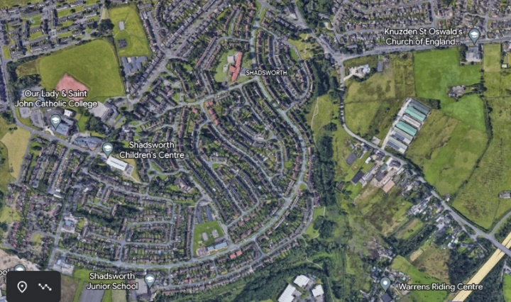

Our School Shadsworth Infants

Key Learning
- To understand how a map works
- To find features around school
- To locate school on a local map
- To identify key features around school
- To know where we live


