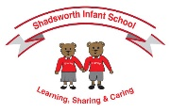
Shadsworth Infant School
Vocabulary Mat
Please use this vocabulary mat to support your child to learn the new vocabulary they need to support them in their current topic.
Year 1, Autumn 1
Science – Everyday Materials  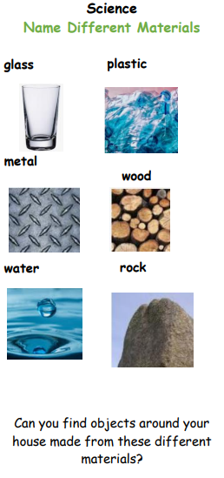  Material Names | Geography – Our School, Our Street  Human features have been built by people  Physical features are natural and would be there even if people weren’t | 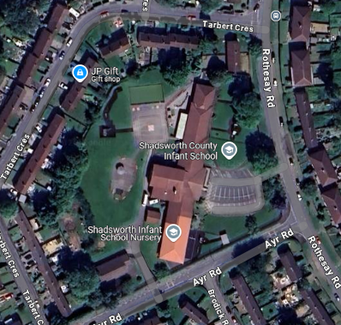  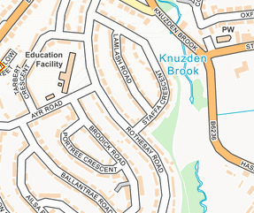
  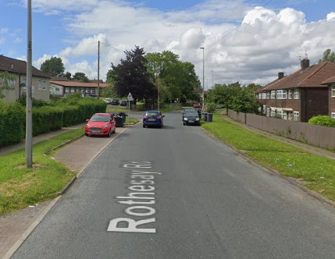  Rothesay Road | 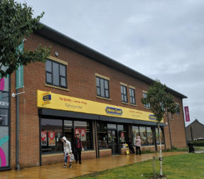  Shop
  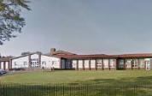  Infant School | 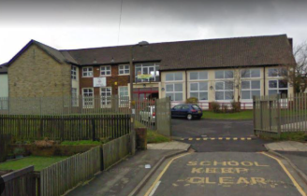  Junior School

