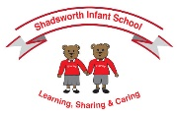
Shadsworth Infant School
Vocabulary Mat
Please use this vocabulary mat to support your child to learn the new vocabulary they need to support them in their current topic.
Year 2 Spring 2
Science – Properties of materials  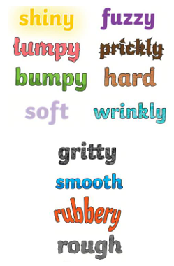 | 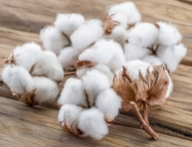  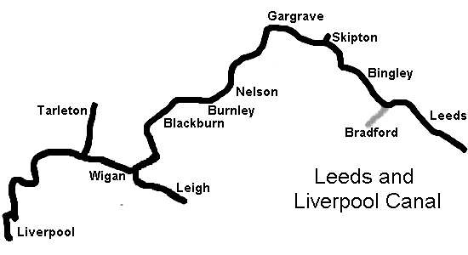  History – Leeds and Liverpool Canal  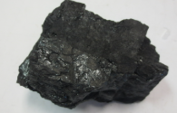  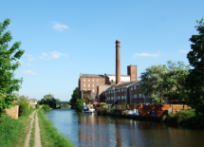  Canal - waterways that are built by people and used for shipping and travel.  River – large natural stream of water  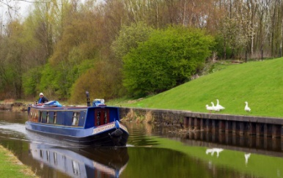  Barge – type of boat on a canal  Deliver – to send or bring something to people  Mills – where things are made  Cotton – type of material  Coal – type of fuel used for burning | 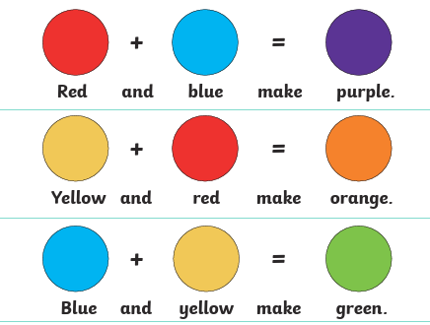  Art – Colour Splash  Artist Study – Jasper Johns  

